BIODATA

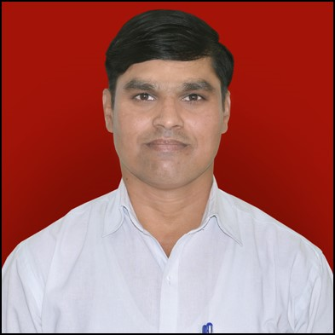

DR. DERE GORAKSHA BABAN

ADD-A/P-Narayangaon, Dere Mala (Ozar Road).

Tal- Junnar, Dist-Pune, Narayangaon-410504.

Mobile No:-9552623881/ 7507107818

E-Mail:- gorakshadr@gmail.com

Designation: Assistant Professor

Educational Qualification:

* Doctor Of Philosophy (Ph.D.) Of Political Science From , Savitribai Phule Pune University Pune - 2017.
* Master of Philosophy (M.Phil.) Of Political Science From Pune University, Pune - 2010.
* State Eligibility Test (SET) Of Political Science From Pune University, Pune - 2013.
* Master Of Arts (M.A) Form Pune University Pune 2006 .With 57.81 % Marks .
* Bachelor Of Arts (B.A) Form Pune University Pune 2004 . With 62.58 % Marks .

Teaching Experience: Three Years Assistant Professor In Political Science At-Prof. Ramkrishna More Arts, Commerce & Science College. Akurdi, Pune-411044.

Classes Taught: UG (F.Y/S.Y./T.Y.B.A.) & PG

Research Area : Indian Politics, International Politics,

Research Articles published In Journals:

|  |  |
| --- | --- |
| * “Pra. Bha.L,Bhole aani Lokshashi Samajvaad-Pra.Dr.Yashwant Sumant   Shabdankan” vicharshalaka, Aug2013-July2014.   * “Rajakaran Aani Mahila”, Parivartnacha Vatsaru, March-2017.   Paper presented in National/ State/ University level Conference:  * “Viksashil Deshatil Suniyojit Shahar, Rashtriy Parisanvad, Pra. Ramkrushana  More College, Akurdi- 44, Jan 2017.   * Process Of Government In Smart City’ Jan 2017.National Seminar.Prof.Ramkrishna More College. Akurdi-44. |  |

Seminars/Workshops/ Training courses attended:

**Participated**

* Center For The Study Of Developing Societies, Post-Poll

Survey Oct-2004.

* State Of Nation Survey Aug-2006.
* National Seminar – 04.
  1. Shri Shiv Chhatrapati College. Junnar 21-22 Feb 2012.
  2. Dada Patil Mahavidyalaya Karjat 10-11 Oct 2013.
  3. Department Of Politics & Public Administration, University Of Pune .14-16 March 2013.
  4. Prof.Ramkrishna More Art’s, Commerce & Science College, Akurdi, Pune-44. 20 & 21 Jan.2017.
* Maharashtra Rajyashastra Va Lokprashasan Parishad 10 To 12 Jan 2014
* State Seminar :- Shri Shiv Chatrapati Mahavidyalay Junnar 22 To 23 Feb 2012
* District Seminar:- Bharatratna Dr.Babashaheb Ambedkar College. 12 Dec-2007

Participation in community/ Social Services:

NSS Camp Program Officer 2 TO 8 Dec 2017 Yelghol (Maval)

Computer Skills: * Basic Knowledge of Computer.